CSC20 HW3 Phone Directory Sp2020

You will implement a phone directory program that reads names of friends and their phone numbers from a file called *names.txt* (given) and stores them in a *HashMap<key,value>* data structure. Key and value are of *String* type Your program needs to be menu based and have the following capabilities:

* display all names in the phone directory;
* add a friend (given name, phone number)
* search for a friend (given name)
* remove a friend (given name)
* change phone number (given name, new phone number)
* merge directories. Given a new directory, update the existing one by updating phone numbers, and adding new friends.

Here is what the menu looks like:

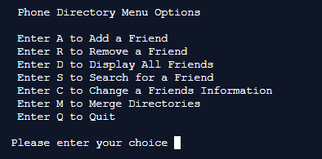

You are given the driver *DirectoryMain.java* thatruns the menu which offers the above features You will need to write the class *Directory.java* and the helper functions in *DirectoryHelper.java.*

The class *Directory.java* instantiates a *HashMap* called *directory* and should implement the following methods:

public Directory(String names) throws FileNotFoundException

//constructor: reads names and numbers from the file into the map

public String getPhoneNumber(String name) //number look up given name public void delete(String name) //remove a directory entry

public void add(String name, String number // add friend given number

public void change(String name, String number) // change number

public void displayDirectory()// display the entire directory in **sorted** order

public void merge(Directory phoneDirectory) // reads from update.txt and merges it with the existing phone directory.

You many also have other helper functions in the class. You need to make use of keySet and Sets to traverse through names in the map. You would also need to use the Collections class to sort.

The names file names.txt and update.txt separate names from phone numbers with a ‘:’. e.g

Armando Lopez : 916-333-4444

Split the input string into two tokens corresponding to the key and value by splitting the input string using *String tokens[]= inline.split(":");*  *tokens[0]* will is name and *tokens[1]* is phone number

Here is what the User Interface for the phone directory should look like:

Main menu: Should accept upper and lower case:

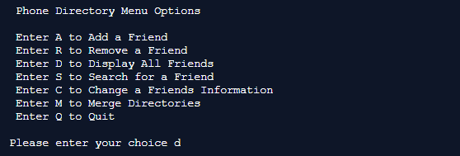

Tests: option d: displayDirectory



Option a: Add a friend

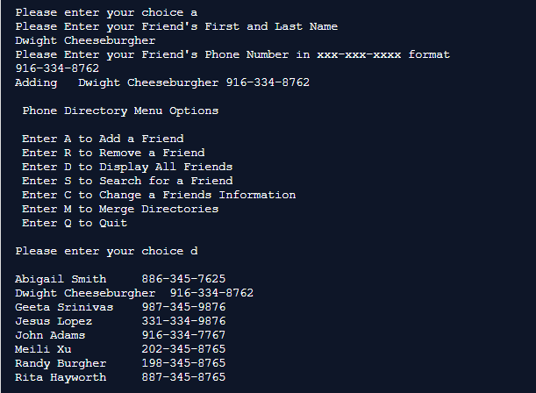

Option r: Remove a friend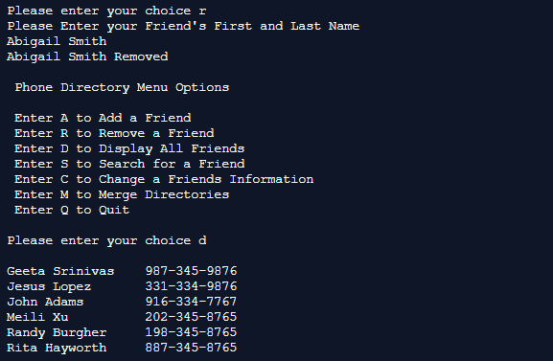

Option s: Search for a friend:

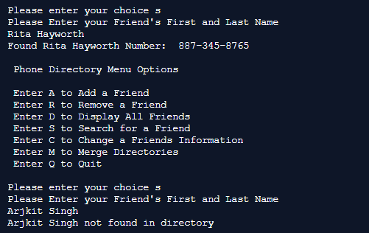

Option c: Change a friends phone number

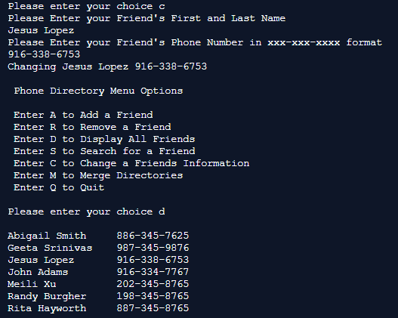

Option m: Merge files (update phone directory)

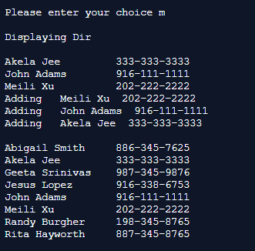

Option q: Quit

